Portfolio

Contents

1 Index Page 2

2 About 2

2.1 No selection 2

2.2 Bio Selection 3

2.3 Qualification expanded 3

2.4 Summary Expanded 4

3 Project 4

4 Contact 5

# Index Page

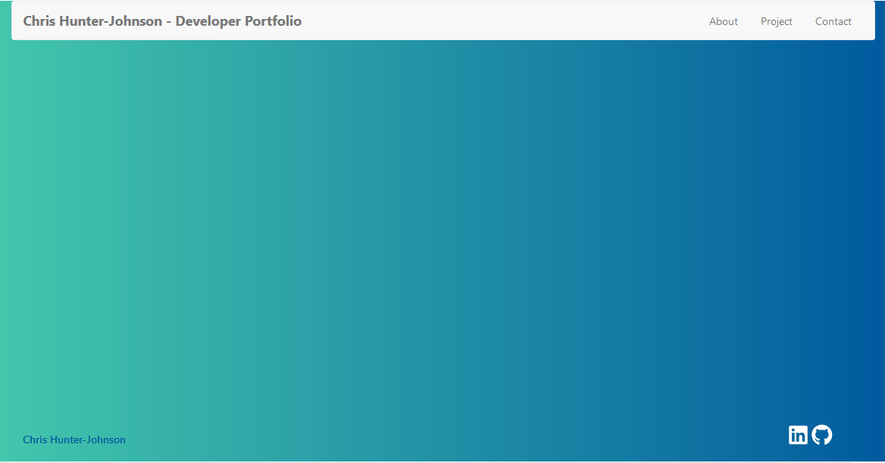

# About

## No selection

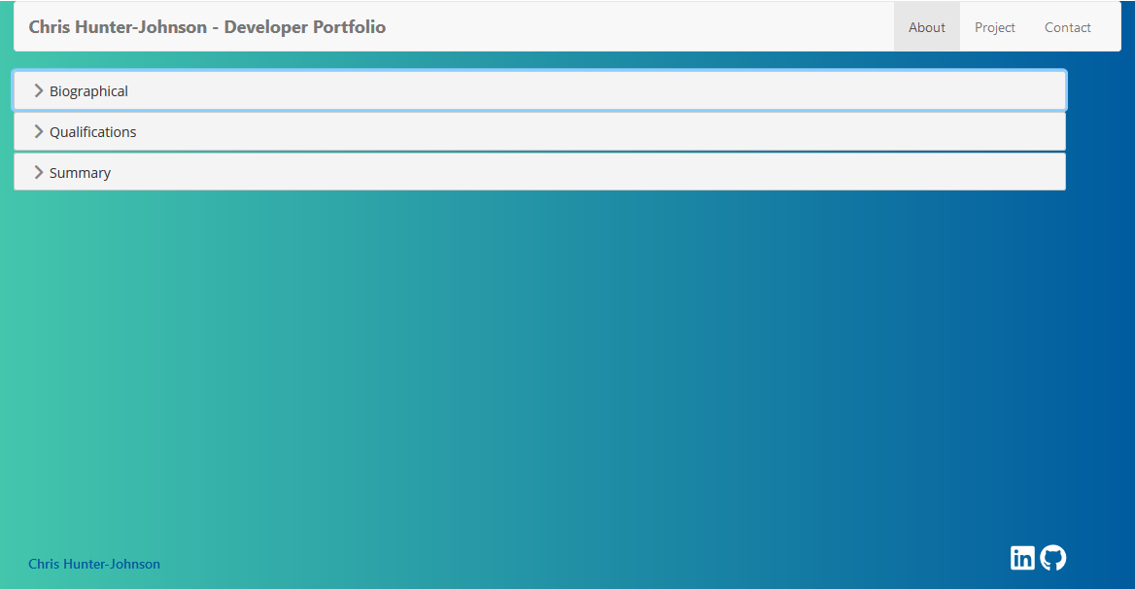

## Bio Selection

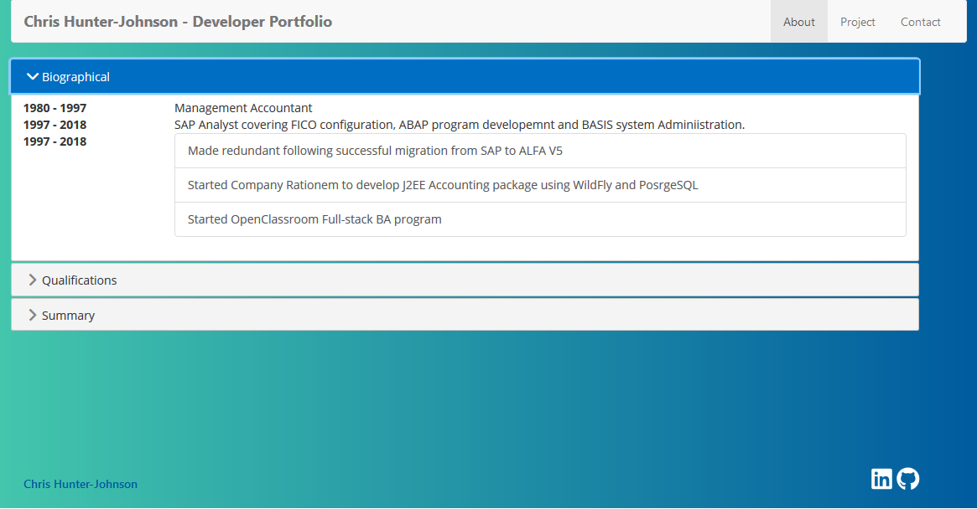

## Qualification expanded

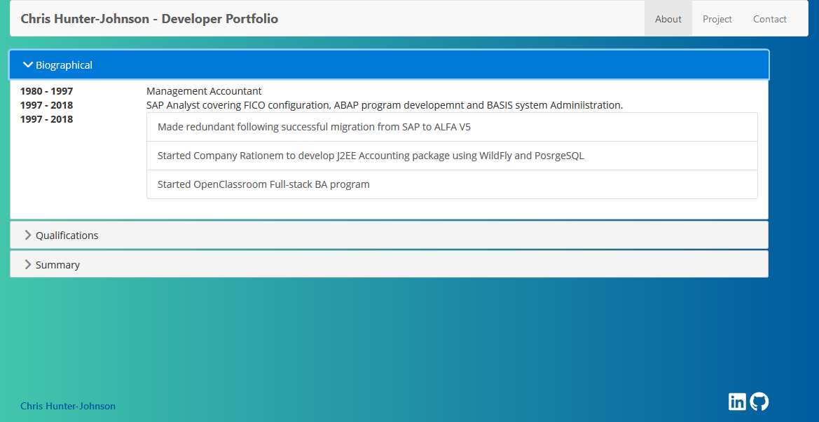

## Summary Expanded

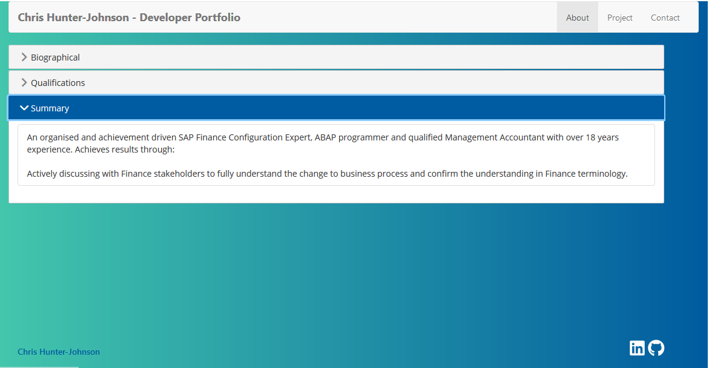

# Project

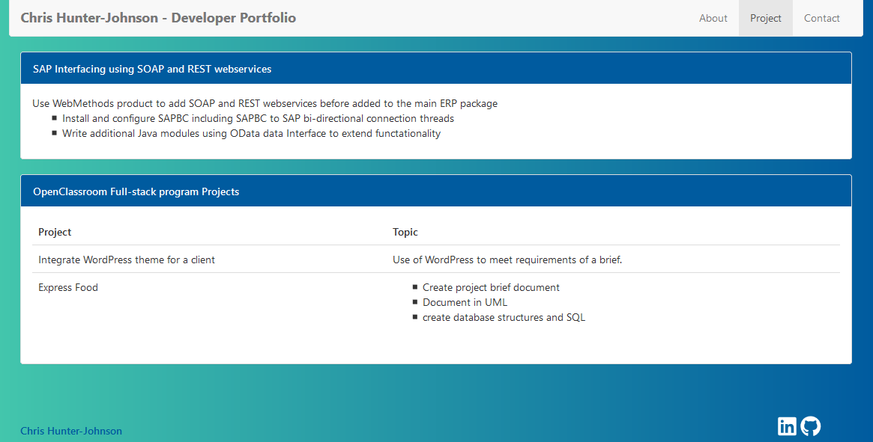

# Contact

